**RISKWISE: A WEB-BASED HAZARD REPORTING AND**

**MONITORING SYSTEM FOR PAMPANGA STATE UNIVERSITY**

A Capstone

Presented to the Faculty of College of

Computing Studies

Pampanga State University

In Partial Fulfillment

of the Requirements for the Degree

**Bachelor of Science in Information Technology**

by:

PABELLO, RONALD KEVIN T.

JIMENEZ, CHRISTIAN ANGELO G.

ANGELO, TROY MATTHEW A.

MALLARI, ANDREI T.

HIPOLITO, ROSE ANNE R.

CANDO, PAULO KURL M.

December 2025

**System Evaluation Based on ISO 25010 Software Quality Standards**

The developed system was evaluated by 49 IT experts and 340 End-user using the ISO/IEC 25010 standards. The evaluation focused on eight (8) software quality characteristics: *Functional Suitability, Performance Efficiency, Compatibility, Usability, Reliability, Security, Maintainability, and Portability.*

|  |  |  |  |  |  |  |
| --- | --- | --- | --- | --- | --- | --- |
| **Functional Suitability** | **SD (1)** | **D (2)** | **A (3)** | **SA (4)** | **WM** | **VI** |
| The system provides all features required for hazard reporting | 2 | 3 | 215 | 169 | 3.41 | *Agree* |
| The information submitted is accurately processed and displayed | 1 | 4 | 210 | 174 | 3.42 | *Agree* |
| The system meets the safety reporting needs of the campus | 2 | 2 | 220 | 156 | 3.41 | *Strongly Agree* |
| **Weighted Average Mean** | | | | | **3.42** | ***Agree*** |

Table 1: Functional Suitability - End-user/IT expert

As shown in Table 1, Question 1, “The system provides the necessary features required for hazard reporting,” obtained a weighted mean of 3.41, interpreted as Agree. This indicates that the respondents found the system capable of delivering the essential functions needed for submitting hazard reports efficiently. Question 2, “The information I submit through the system is processed accurately,” received a weighted mean of 3.43, interpreted as Agree. This suggests that the system processes and stores user data reliably, providing consistent and accurate results whenever a report is submitted or retrieved. Meanwhile, Question 3, “The system meets its intended purpose in supporting hazard reporting tasks,” obtained a weighted mean of 3.41, which is interpreted as Agree. This reveals that users view the system as relevant and sufficient in achieving its purpose, helping them complete their reporting tasks without unnecessary difficulty. Overall, the Weighted Average Mean (WAM) for Functional Suitability is 3.42, verbally interpreted as Agree. This implies that users are generally satisfied with the system’s functions, finding them appropriate, complete, and useful for fulfilling the requirements of hazard reporting.

|  |  |  |  |  |  |  |
| --- | --- | --- | --- | --- | --- | --- |
| **Performance Efficiency** | **SD (1)** | **D (2)** | **A (3)** | **SA (4)** | **WM** | **VI** |
| The system loads pages quickly. | 3 | 2 | 180 | 204 | 3.49 | *Agree* |
|  | 3 | 5 | 210 | 171 | 3.40 | *Agree* |
| **Weighted Average Mean** | | | | | **3.45** | ***Agree*** |

Table 2: Performance Efficiency - End-user/IT Expert

As presented in Table 2, Question 1, “The system loads pages quickly,” obtained a weighted mean of 3.49, interpreted as Agree. This shows that users experienced efficient loading times when navigating through the system, indicating that it responds well even with multiple functions running. Question 2, “The system responds efficiently to user actions,” received a weighted mean of 3.40, interpreted as Agree. This means that the majority of respondents observed smooth and responsive interactions, such as submitting reports, opening menus, or retrieving previous submissions. Overall, the Weighted Average Mean (WAM) for Performance Efficiency is 3.45, interpreted as Agree. This implies that the system is capable of handling user actions promptly and performs well under typical usage conditions.

|  |  |  |  |  |  |  |
| --- | --- | --- | --- | --- | --- | --- |
| **Compatibility** | **SD (1)** | **D (2)** | **A (3)** | **SA (4)** | **WM** | **VI** |
| The system works well on different browsers (Chrome, Firefox, Edge). | 3 | 4 | 220 | 162 | 3.39 | *Agree* |
| The system does not conflict with device configurations | 4 | 5 | 200 | 180 | 3.43 | *Agree* |
| **Weighted Average Mean** | | | | | **3.41** | ***Agree*** |

Table 3: Compatibility- End-user/IT Expert

Based on Table 3, Question 1, “The system works across commonly used browsers,” received a weighted mean of 3.39, interpreted as Agree. This shows that users were able to access the system using different browsers without encountering major compatibility problems. Question 2, “The system does not conflict with device configurations,” obtained a weighted mean of 3.43, also interpreted as Agree. This suggests that users experienced minimal issues regardless of the device they used, whether laptops, desktop computers, or mobile phones. In summary, the Weighted Average Mean (WAM) for Compatibility is 3.41, interpreted as Agree. This indicates that the system performs consistently across various platforms and setups, allowing wider usability among diverse users.

|  |  |  |  |  |  |  |
| --- | --- | --- | --- | --- | --- | --- |
| **Usability** | **SD (1)** | **D (2)** | **A (3)** | **SA (4)** | **WM** | **VI** |
| The system is easy to learn for first-time users. | 3 | 4 | 255 | 127 | 3.30 | *Agree* |
| The interface is clear and understandable. | 3 | 5 | 250 | 131 | 3.31 | *Agree* |
| Icons , buttons and labels are clear and meaningful |  |  | 2 | 1 | 3.33 | *Agree* |
| **Weighted Average Mean** | | | | | **3.31** | ***Agree*** |

Table 4: Usability - End-user/IT Expert

According to Table 4, Question 1, “The system is easy to learn for first-time users,” received a weighted mean of 3.30, interpreted as Agree. This indicates that users found the system simple to understand even without prior experience. Question 2, “The interface is clear and understandable,” obtained a weighted mean of 3.31, interpreted as Agree. This means that the majority of respondents found the layout, labels, and overall design of the system easy to follow, reducing confusion during usage. Overall, the Weighted Average Mean (WAM) for Usability is 3.31, interpreted as Agree. This implies that the system is user-friendly, visually clear, and designed in a way that allows users to complete tasks comfortably.

|  |  |  |  |  |  |  |
| --- | --- | --- | --- | --- | --- | --- |
| **Reliability** | **SD (1)** | **D (2)** | **A (3)** | **SA (4)** | **WM** | **VI** |
| The system runs without crashes or errors. | 3 | 3 | 210 | 173 | 3.44 | *Agree* |
| Submitted reports are saved accurately and securely | 2 | 4 | 215 | 168 | 3.44 | *Agree* |
| **Weighted Average Mean** | | | | | **3.44** | ***Agree*** |

Table 5: Reliability - End-user/IT Expert

As shown in Table 5, Question 1, “The system runs without crashes or errors,” obtained a weighted mean of 3.44, interpreted as Agree. This shows that users experienced stable system performance, with minimal interruptions while using the platform. Question 2, “Reports are saved accurately,” received a weighted mean of 3.44, also interpreted as Agree. This indicates that users trust the system’s ability to retain and reflect their reports consistently, without errors or data loss. Overall, the Weighted Average Mean (WAM) for Reliability is 3.44, interpreted as Agree. This implies that the system is dependable and functions continuously without major technical issues. Security As presented in Table 6, Question 1, “User data is protected from unauthorized access,” obtained a weighted mean of 3.53, interpreted as Strongly Agree. This suggests that users believe their personal information and submitted reports are kept safe within the system. Question 2, “The login and authentication process is secure,” received a weighted mean of 3.49, interpreted as Agree. This indicates that users feel confident about the way the system validates accounts and prevents unauthorized entry. Overall, the Weighted Average Mean (WAM) for Security is 3.51, interpreted as Strongly Agree. This implies that security is the strongest aspect of the system, gaining the highest level of user confidence among all ISO categories.

|  |  |  |  |  |  |  |
| --- | --- | --- | --- | --- | --- | --- |
| **Security** | **SD (1)** | **D (2)** | **A (3)** | **SA (4)** | **WM** | **VI** |
| User data is protected from unauthorized access. | 1 | 2 | 175 | 211 | 3.53 | *Strongly Agree* |
| The login and authentication processes are secure | 2 | 3 | 180 | 204 | 3.49 | *Agree* |
| **Weighted Average Mean** | | | | | **3.51** | ***Strongly Agree*** |

Table 6: Security - End-user/IT Expert

As presented in Table 6, Question 1, “User data is protected from unauthorized access,” obtained a weighted mean of 3.53, interpreted as Strongly Agree. This suggests that users believe their personal information and submitted reports are kept safe within the system. Question 2, “The login and authentication process is secure,” received a weighted mean of 3.49, interpreted as Agree. This indicates that users feel confident about the way the system validates accounts and prevents unauthorized entry. Overall, the Weighted Average Mean (WAM) for Security is 3.51, interpreted as Strongly Agree. This implies that security is the strongest aspect of the system, gaining the highest level of user confidence among all ISO categories.

|  |  |  |  |  |  |  |
| --- | --- | --- | --- | --- | --- | --- |
| **Maintainability (IT Expert)** | **SD (1)** | **D (2)** | **A (3)** | **SA (4)** | **WM** | **VI** |
| The system can be updated or modified easily when requirements change. | 1 | 3 | 215 | 170 | 3.42 | *Agree* |
| The code structure supports efficient debugging | 2 | 4 | 255 | 158 | 13.38 | *Agree* |
| **Weighted Average Mean** | | | | | **3.40** | ***Agree*** |

Table 7: Maintainability - IT Expert

As shown in Table 7, Question 1, “The system can be updated easily,” received a weighted mean of 3.42, interpreted as Agree. This means IT experts found the system easy to modify or revise whenever changes are required. Question 2, “The code structure supports efficient debugging,” obtained a weighted mean of 3.38, interpreted as Agree. This reflects that the system’s internal structure is organized enough to support troubleshooting and future enhancements. Overall, the Weighted Average Mean (WAM) for Maintainability is 3.40, interpreted as Agree. This implies that the system can accommodate updates and improvements with minimal difficulty.

|  |  |  |  |  |  |  |
| --- | --- | --- | --- | --- | --- | --- |
| **Portablity** | **SD (1)** | **D (2)** | **A (3)** | **SA (4)** | **WM** | **VI** |
| The system works properly when accessed on different computers. | 2 | 4 | 210 | 173 | 3.43 | *Agree* |
| The system can be deployed in other campuses with minimal changes | 2 | 3 | 205 | 179 | 3.44 | *Agree* |
| **Weighted Average Mean** | | | | | **3.44** | ***Agree*** |

Table 8: Portablity - End-user/IT Expert

According to Table 8, Question 1, “The system works properly on different computers,” obtained a weighted mean of 3.43, interpreted as Agree. This indicates that users were able to operate the system regardless of the computers they used. Question 2, “The system can be deployed in other campuses with minimal adjustments,” received a weighted mean of 3.44, also interpreted as Agree. This suggests that respondents believe the system can be transferred to other departments or campuses with little to no conflict in operation. Overall, the Weighted Average Mean (WAM) for Portability is 3.44, interpreted as Agree. This implies that the system has strong potential for expansion and replication in other institutional settings.

**CHAPTER 5**

**SUMMARY, CONCLUSION, AND RECOMMENDATIONS**

The study concludes that the RiskWise Hazard Reporting System is a functional, reliable, and user-friendly platform capable of improving hazard reporting processes within the institution. The high ratings across all ISO/IEC 25010 categories confirm that the system meets software quality expectations and performs efficiently under typical usage conditions. The results demonstrate that the system is ready for institutional deployment and has the potential to significantly enhance campus safety operations. The study concludes that the RiskWise Hazard Reporting System is a functional, reliable, and user-friendly platform capable of improving hazard reporting processes within the institution. The high ratings across all ISO/IEC 25010 categories confirm that the system meets software quality expectations and performs efficiently under typical usage conditions. The results demonstrate that the system is ready for institutional deployment and has the potential to significantly enhance campus safety operations.

The research implies that the RiskWise Hazard Reporting System is a working, trustworthy, and approachable platform that can better the reporting process of hazard within the establishment. The system's high scores in all ISO/IEC 25010 categories prove that it complies with software quality and performs well even during the usual working conditions. The outcomes indicate that the system is fit for deployment in the organization and has the capability of greatly improving safety operations on the campus.

A total of 389 respondents participated in the study:

* 340 Students
* 49 IT Expert

The study used purposive sampling and evaluated the system using the **ISO/IEC 30141 IoT Main Characteristics Criteria**. The overall rating was **4.43**, interpreted as “**Highly Acceptable**.” Results showed that the IoT-based device significantly supported the work of farmers and seedling producers. The system functioned well during testing with no major issues. These findings confirm the potential of SmartSprout to enhance and modernize seedling production.

**Conclusion**

The evaluation reaches a conclusion that the RiskWise Hazard Reporting System is a platform that is functional, reliable, and easy to use, and it can help to improve the reporting of hazards in the institution. The excellent scores obtained in all ISO/IEC 25010 categories indicate that the system not only meets the expectations of software quality but also performs well in the typical usage conditions. The findings indicate that the system is prepared for deployment in the institution and has the potential to provide great support to the operations of the safety team on campus.

**Recommendations**

Based on the results and conclusions of the study, the following recommendations are provided to guide future developers and researchers:

1. **For System Enhancement**

* Improve administrative visual tools such as analytics graphs and hazard heatmaps. Add advanced search and filtering functions for administrators. Integrate optional voice input for hazard descriptions. Implement multi-factor authentication for enhanced account security. Develop an offline capture mode for future versions, if applicable.

1. **For Institutional Implementation**

* Conduct orientation and training for safety officers and designated personnel. Promote system usage through campus-wide announcements and student briefings. Integrate RiskWise with existing emergency response protocols. Encourage regular feedback from users to guide future improvements.

1. **For future researchers**

* Explore building a native mobile application for additional mobility features. Investigate AI-based hazard classification to automate categorization. Expand the system for multi-campus deployment. Conduct a longitudinal study to assess long-term system effectiveness.

**References**

Adetunji, O., Ajaegbu, C., Otuneme, N., & Omotosho, O. (2020). Dawning of Progressive Web Applications (PWA): Edging Out the Pitfalls of Traditional Mobile Development. American Scientific Research Journal for Engineering, Technology, and Sciences. Retrieved from <https://asrjetsjournal.org>

Blessing, M. (2024). Progressive Web Apps (PWAs) and Their Impact on User Experience. ResearchGate. Retrieved from <https://www.researchgate.net/publication/383661054>

Castillo, R. D., & Ferrer, M. A. (2022). Optimizing Safety Systems Using Modern Web Technologies: A Case Study on PWAs. Journal of Web Systems and Safety, 18(2), 114–128.

Fauzan, R., Krisnahati, I., Nurwibowo, B., & Wibowo, D. (2021). A Systematic Literature Review on Progressive Web Application Practice and Challenges. Jurnal Teknik ITS, 10(1). Retrieved from <https://iptek.its.ac.id/index.php/jts/article/view/13904>

Fauzan, R., Krisnahati, I., Nurwibowo, B., & Wibowo, D. (2021). A Systematic Literature Review on Progressive Web Application Practice and Challenges. Jurnal Teknik ITS, 10(1). Retrieved from <https://iptek.its.ac.id/index.php/jts/article/view/13904>

Hernandez, G., & Zhao, L. (2022). Real-Time Risk Identification and Mitigation in Urban Communities. International Journal of Risk and Safety Management, 24(3), 77–89.

Ignaco, M. A. E. (2019). Development of Mobile Application for Incident Reporting. In Smart Computing and Communication. Springer. <https://link.springer.com/chapter/10.1007/978-981-97-4581-4_14>

Kim, J., Lee, S., & Park, J. (2023). Real-time Feedback on Mobile Application Use for Emergency Management Affects Door-to-Needle Time and Functional Outcomes in Acute Ischemic Stroke. PubMed. <https://pubmed.ncbi.nlm.nih.gov/36801498/>

Lin, C., Yang, J., & Stack, C. M. (2022). Smartphone App in Stroke Management: A Narrative Updated Review. Journal of Stroke, 24(4), 215–222. <https://www.j-stroke.org/journal/view.php?doi=10.5853/jos.2022.01410>

Malhotra, T. (2023). Progressive Web Apps: Transforming Mobile and Desktop User Experiences. TechFront Journal of Software Engineering, 11(4), 45–56.

Marchetto, T., & Morandini, M. (2024). User Perceptions of Progressive Web App Features: An Analytical Approach and a Systematic Literature Review. In Digital Transformation in Software Systems (pp. 203–220). Springer. <https://link.springer.com/chapter/10.1007/978-981-97-4581-4_14>

Navarro de Corcuera, L., Barbero-Barrera, M., Campos Hidalgo, A., et al. (2022). Assessment of the Adequacy of Mobile Applications for Disaster Reduction. Environment, Development and Sustainability, 24(6), 9312–9330. <https://link.springer.com/article/10.1007/s10668-021-01697-2>

Panwar, V. (2024). Leveraging Progressive Web Apps (PWAs) for Enhanced User Experience and Performance: A Comprehensive Analysis. ResearchGate. <https://www.researchgate.net/publication/379479846>

Singh, R., & Amador, K. (2021). Barriers to Effective Incident Reporting in Construction and Corporate Sectors. Risk & Compliance Review, 29(1), 23–39.

Tan, M. L., Prasanna, R., Stock, K., & Johnston, D. M. (2020). Evaluating the Usability and Usefulness of a Storm Preparedness and Risk Assessment Mobile App. ResearchGate. <https://www.researchgate.net/publication/387799441>

Wang, Y., Li, J., Zhao, X., Feng, G., & Luo, X. (2020). Using Mobile Phone Data for Emergency Management: A Systematic Literature Review. International Journal of Disaster Risk Reduction, 48, 101612. <https://pmc.ncbi.nlm.nih.gov/articles/PMC7493063/>

**Appendix A.**

Request Letters (Adviser)

Scanned letter

**Appendix B.**

Plagiarism Checker Certificate

Scanned letter

**Appendix C.**

Grammar Check Certificate

Scanned letter

**Appendix D.**

System Evaluation Questionnaire (Quantitative)

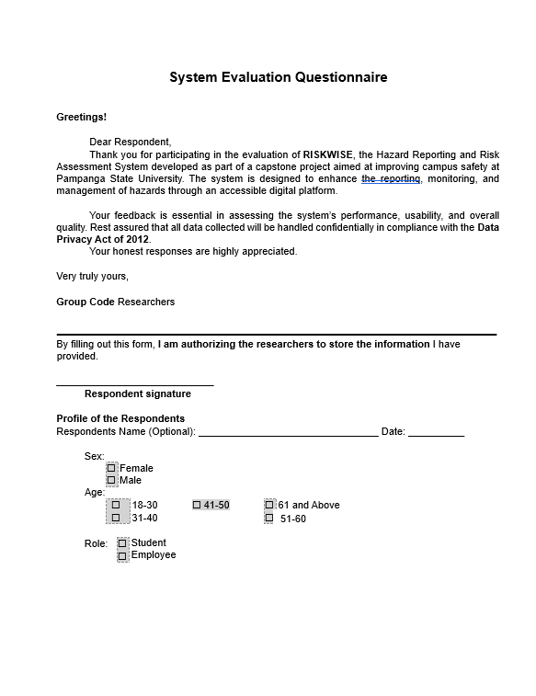

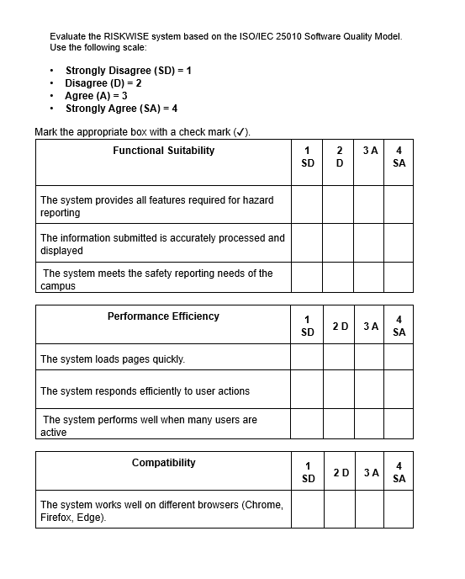

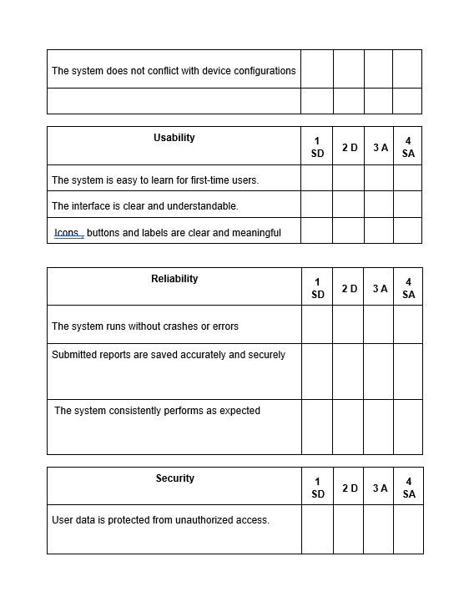

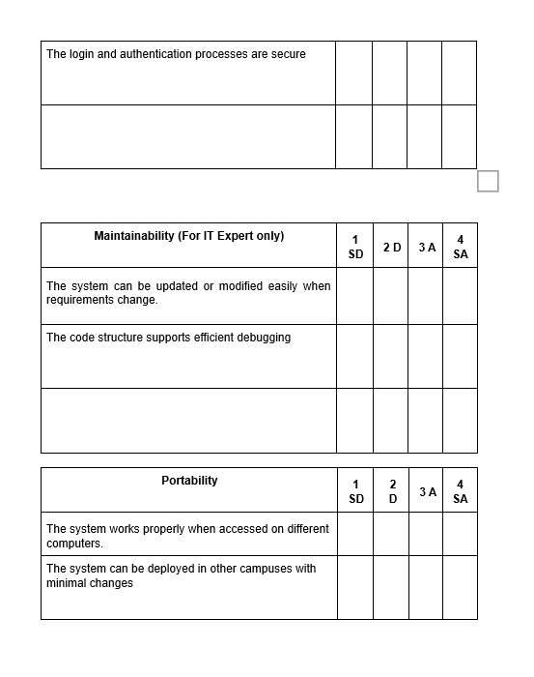

**Appendix E.**

System Screenshots and Flowcharts

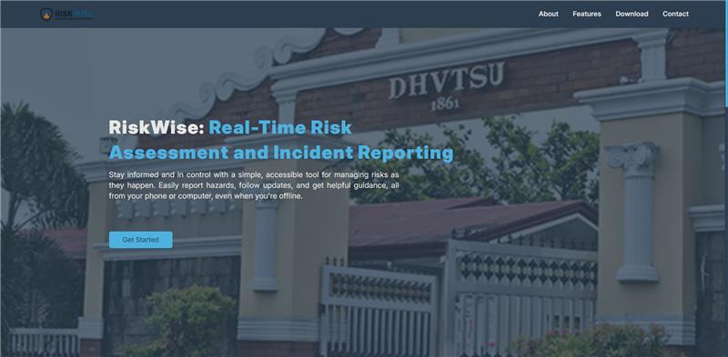

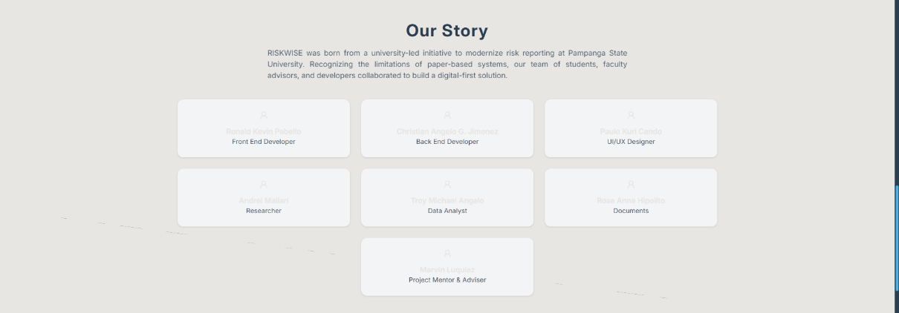



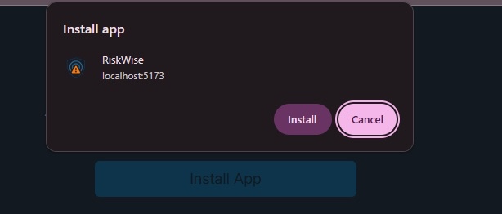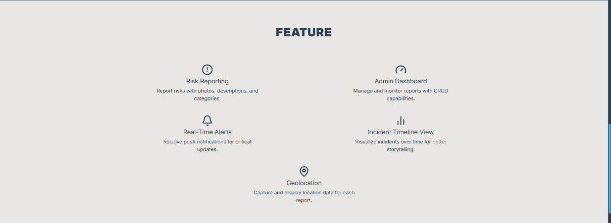



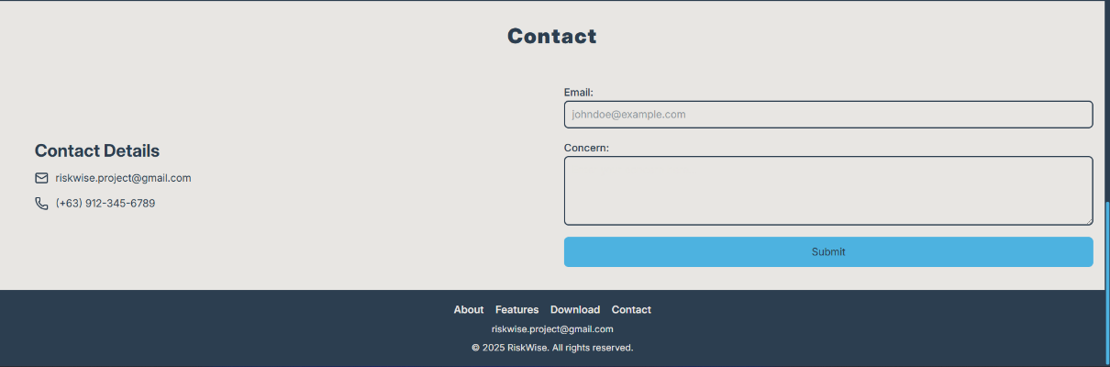

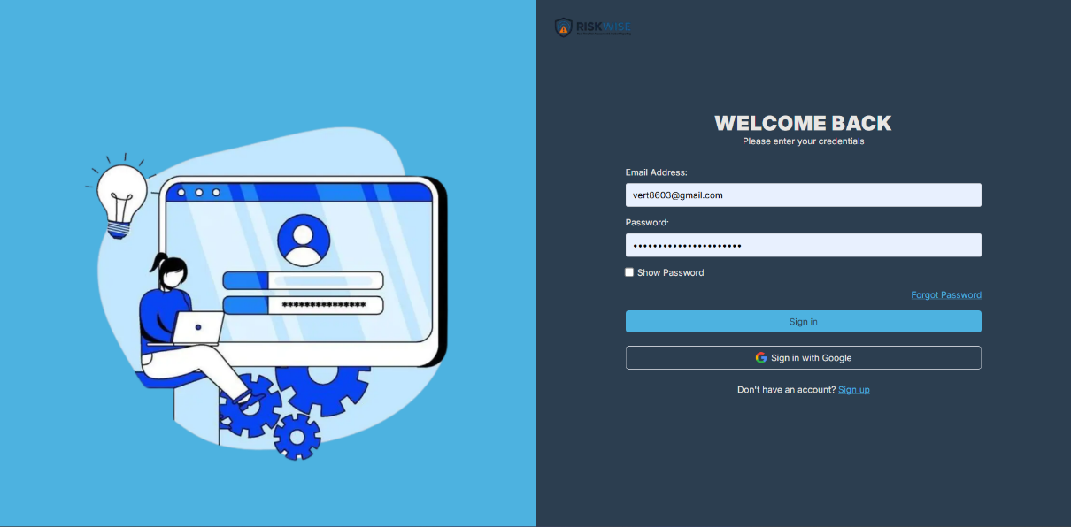



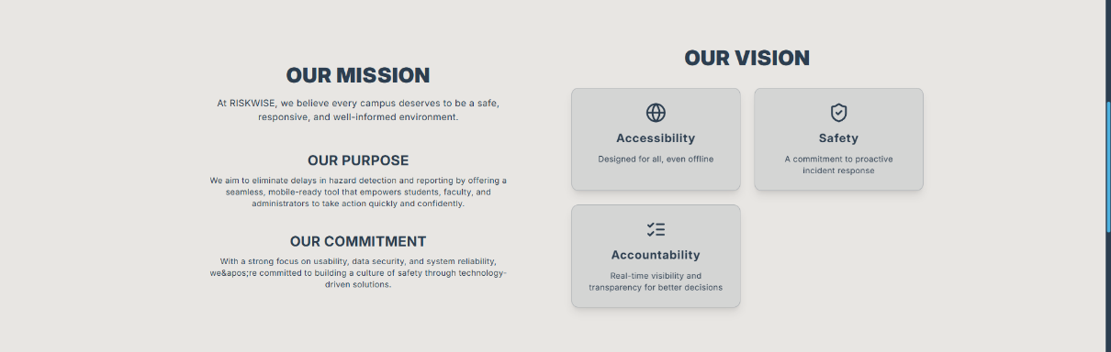

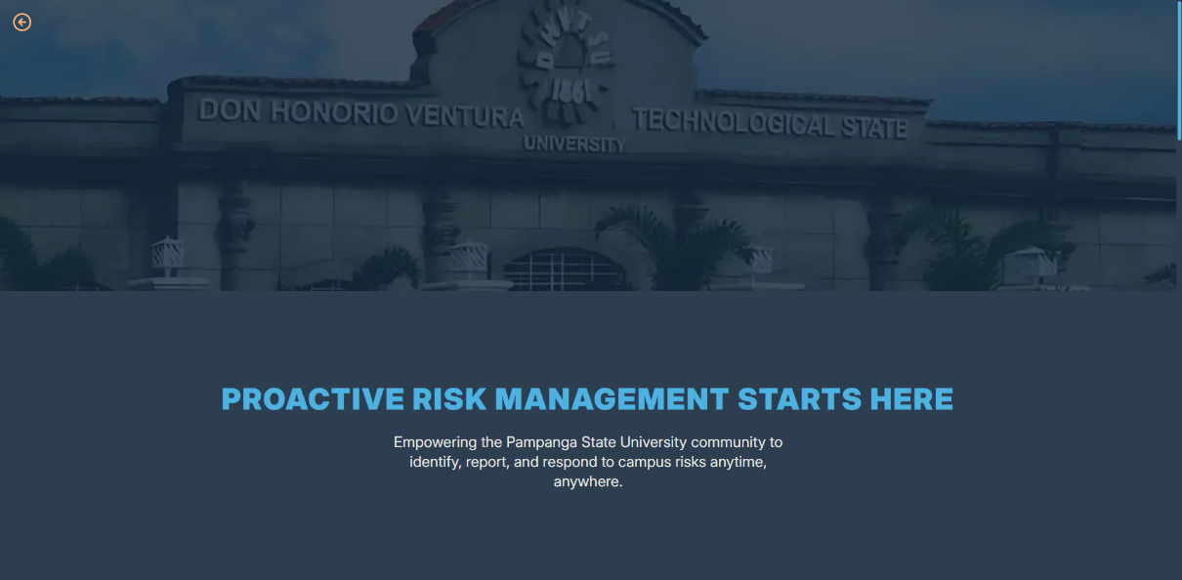





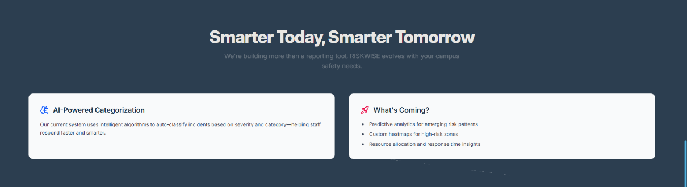

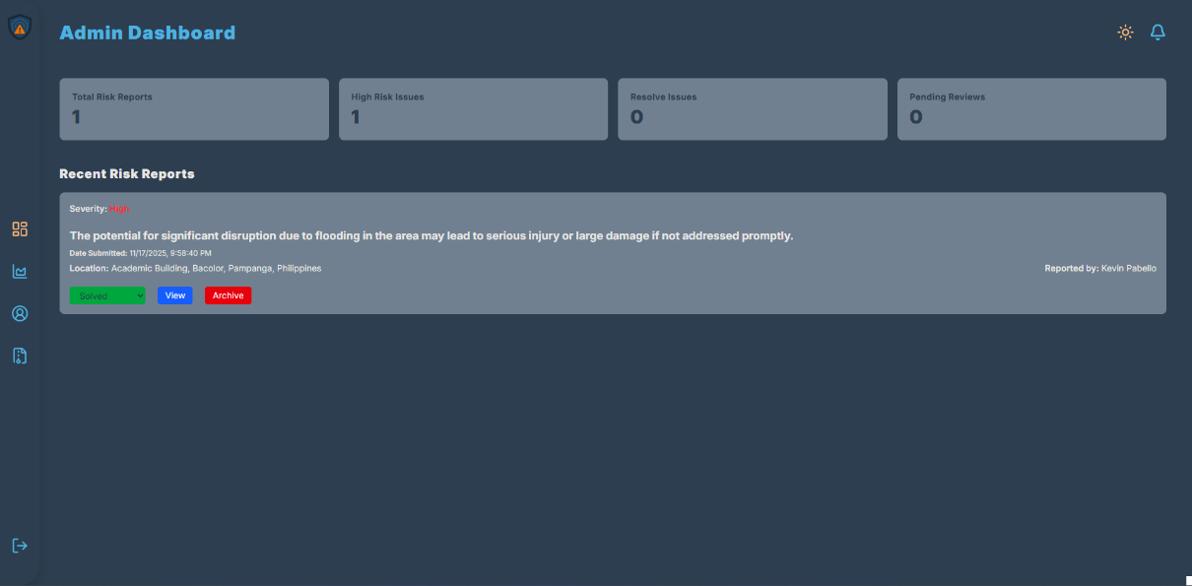

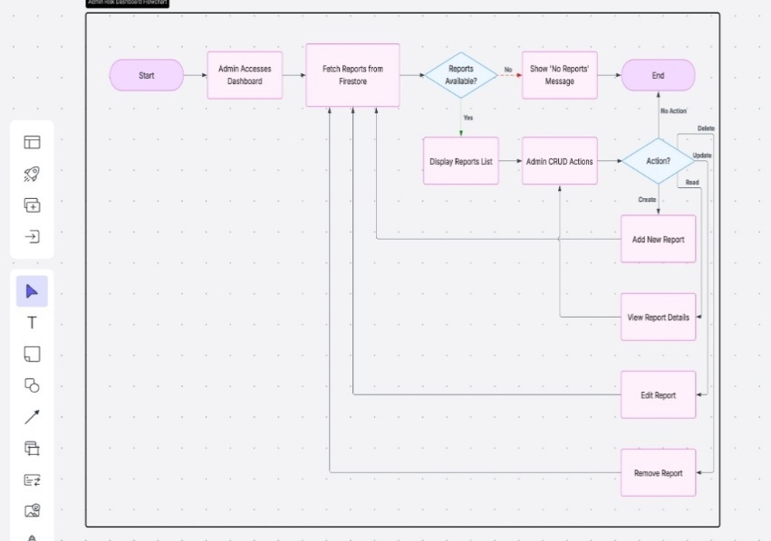

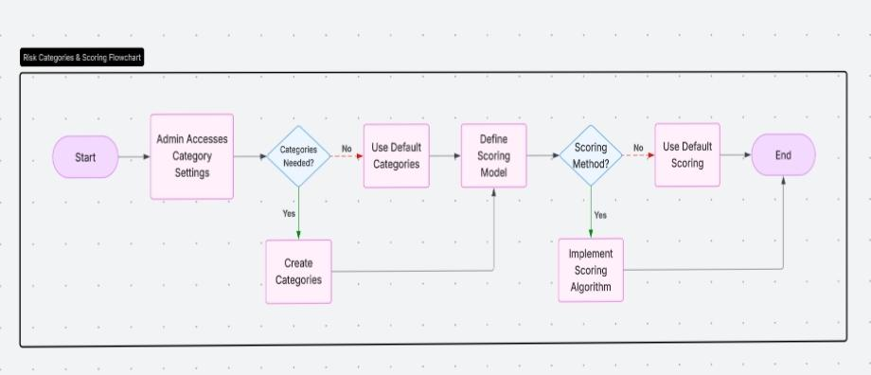

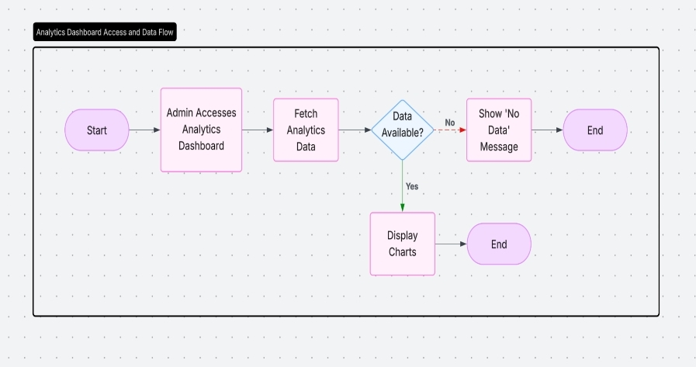

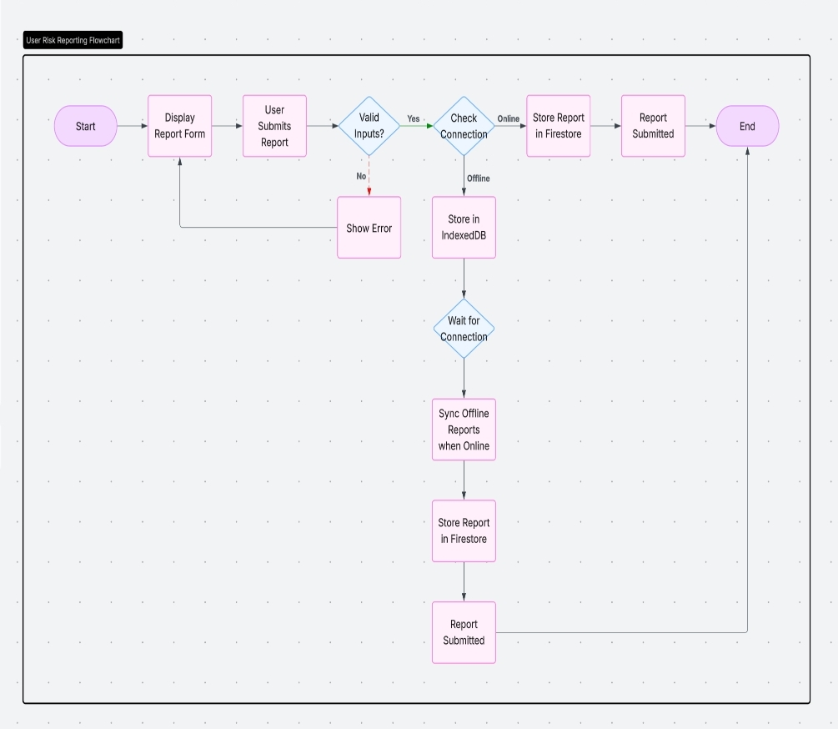

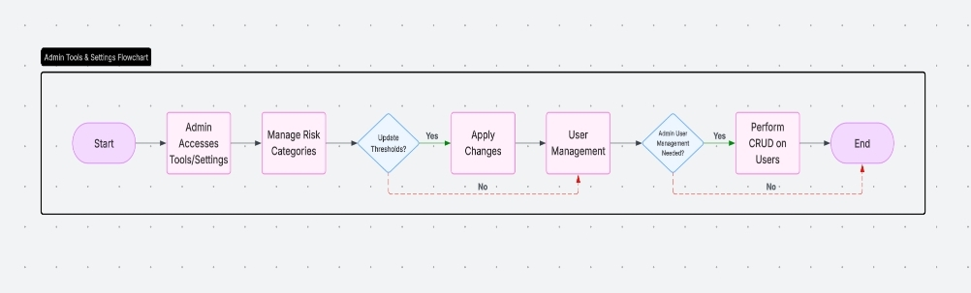

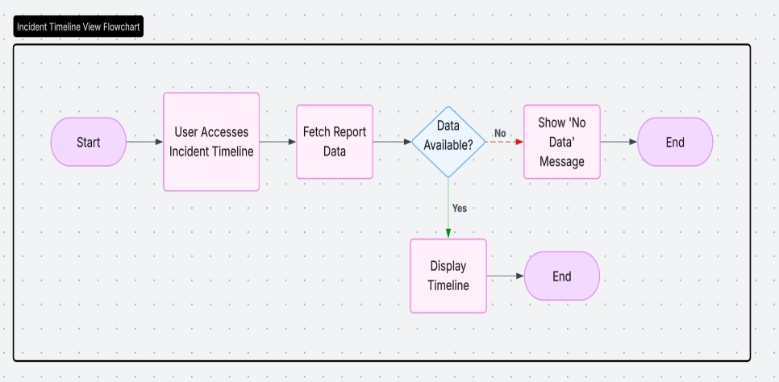

**Appendix F.**

User Manual and Admin Manual  
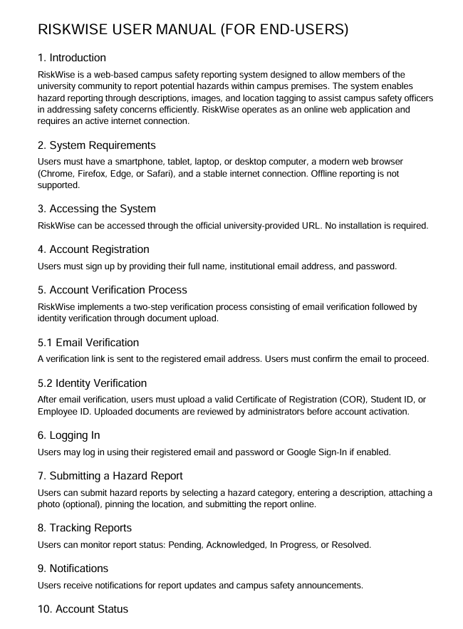  
  
  
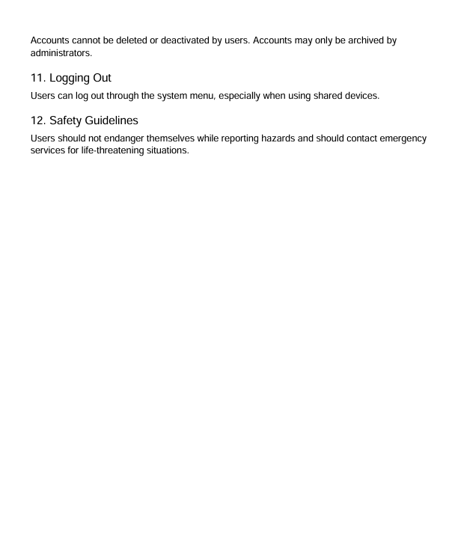

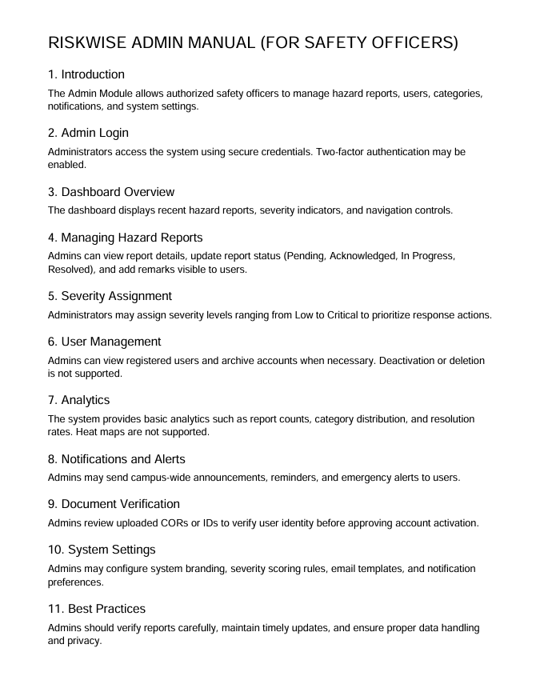

**Appendix G.**

Sample Source Code

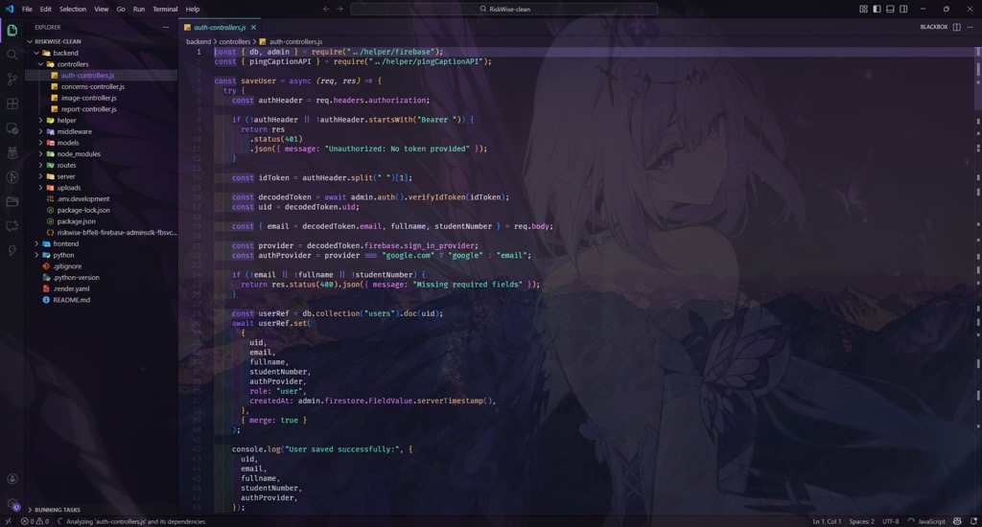

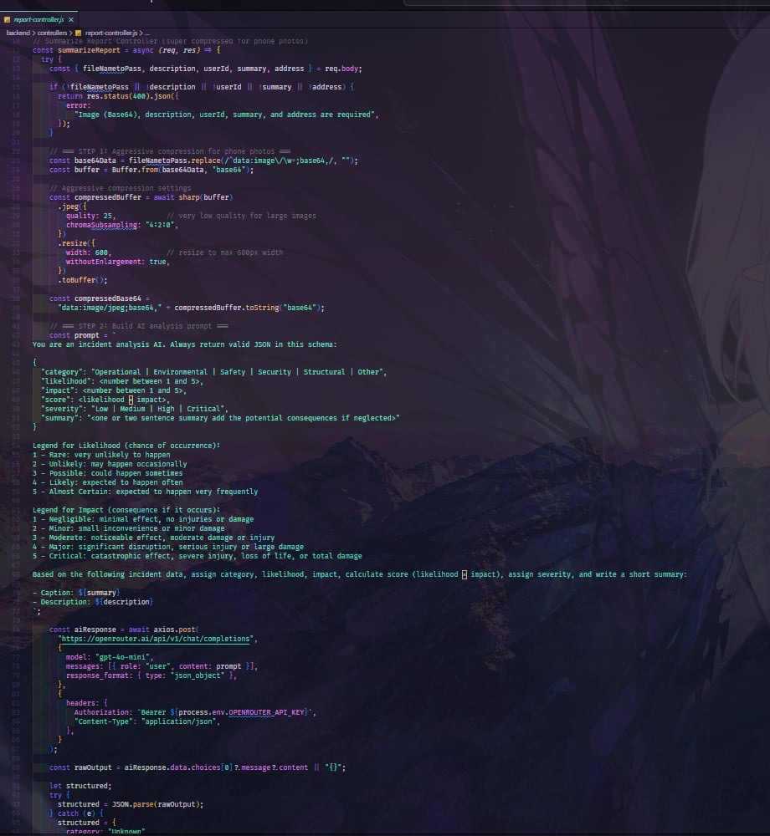

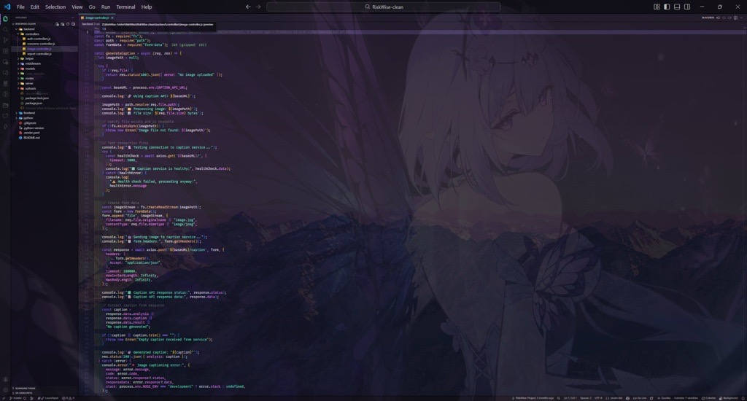

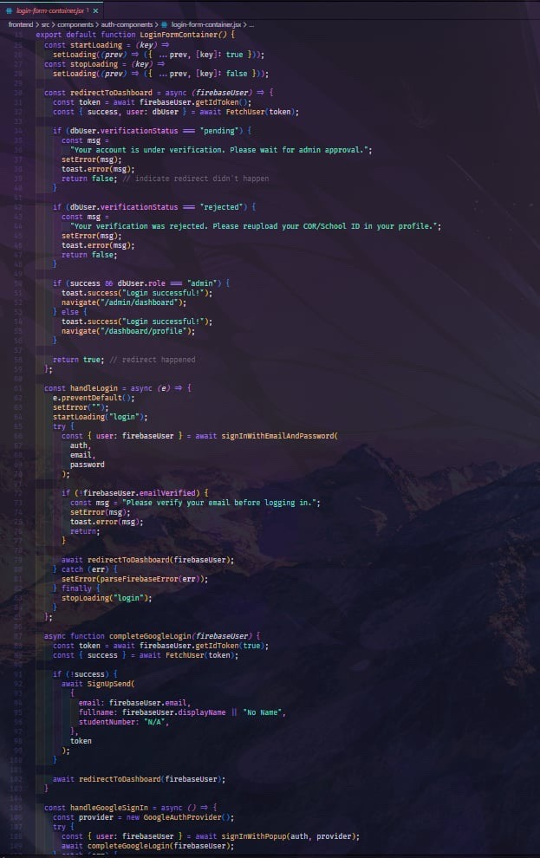

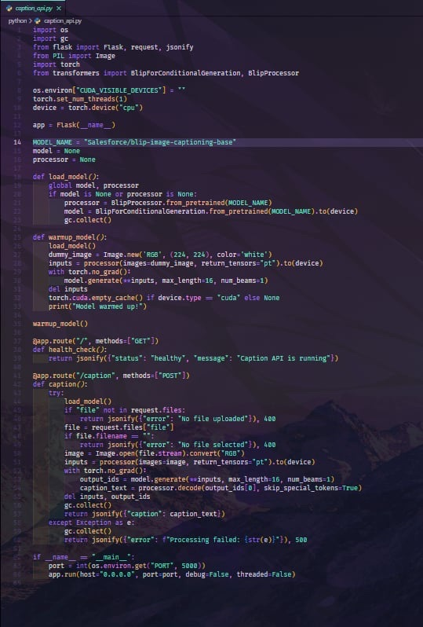

**Appendix H.**

IT Expert Curriculum Vitae

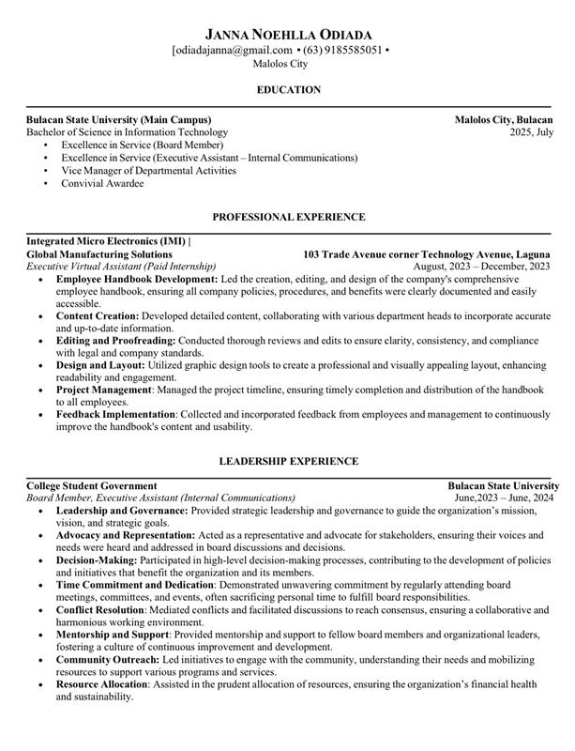

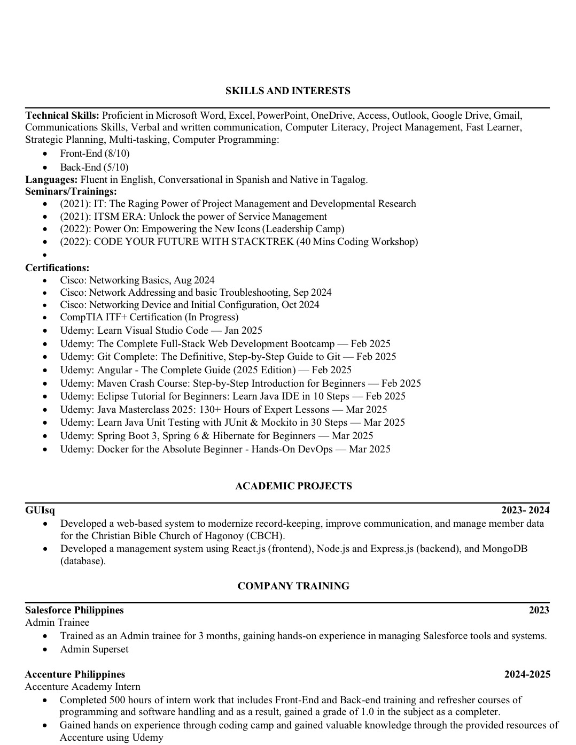

**  
  
  
  
  
  
  
  
  
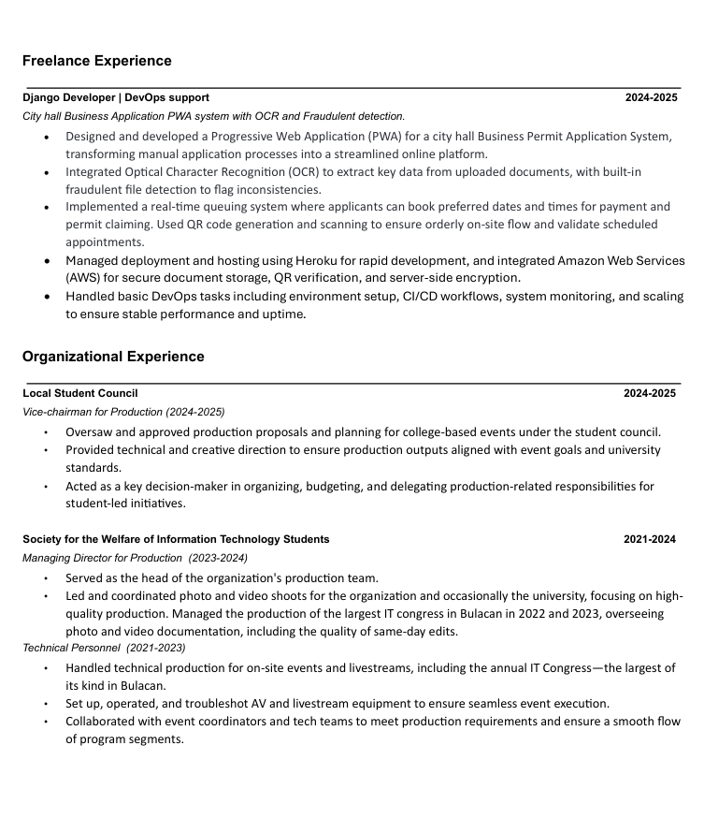  
  
  
  
  
  
  
  
  
  
  
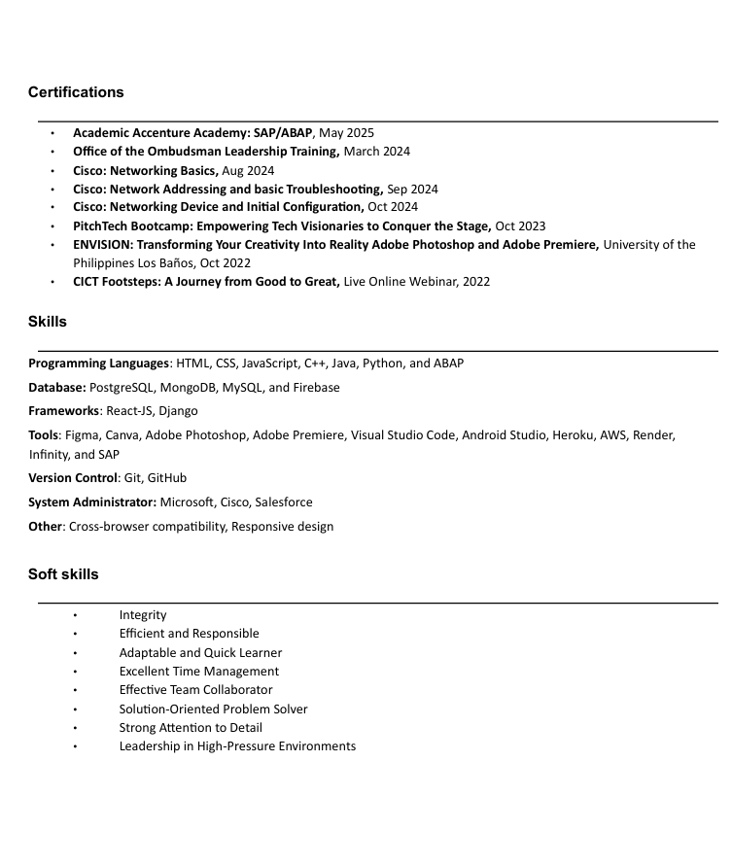**

**Appendix I.**

Researchers Curriculum Vitae

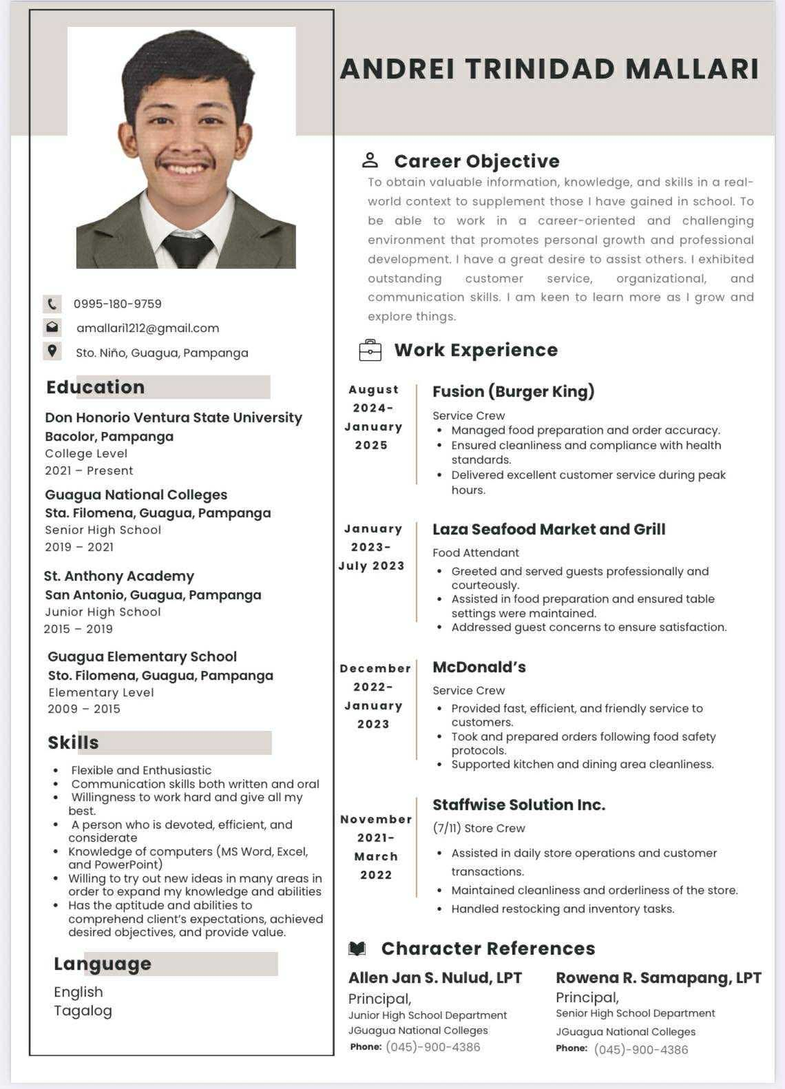

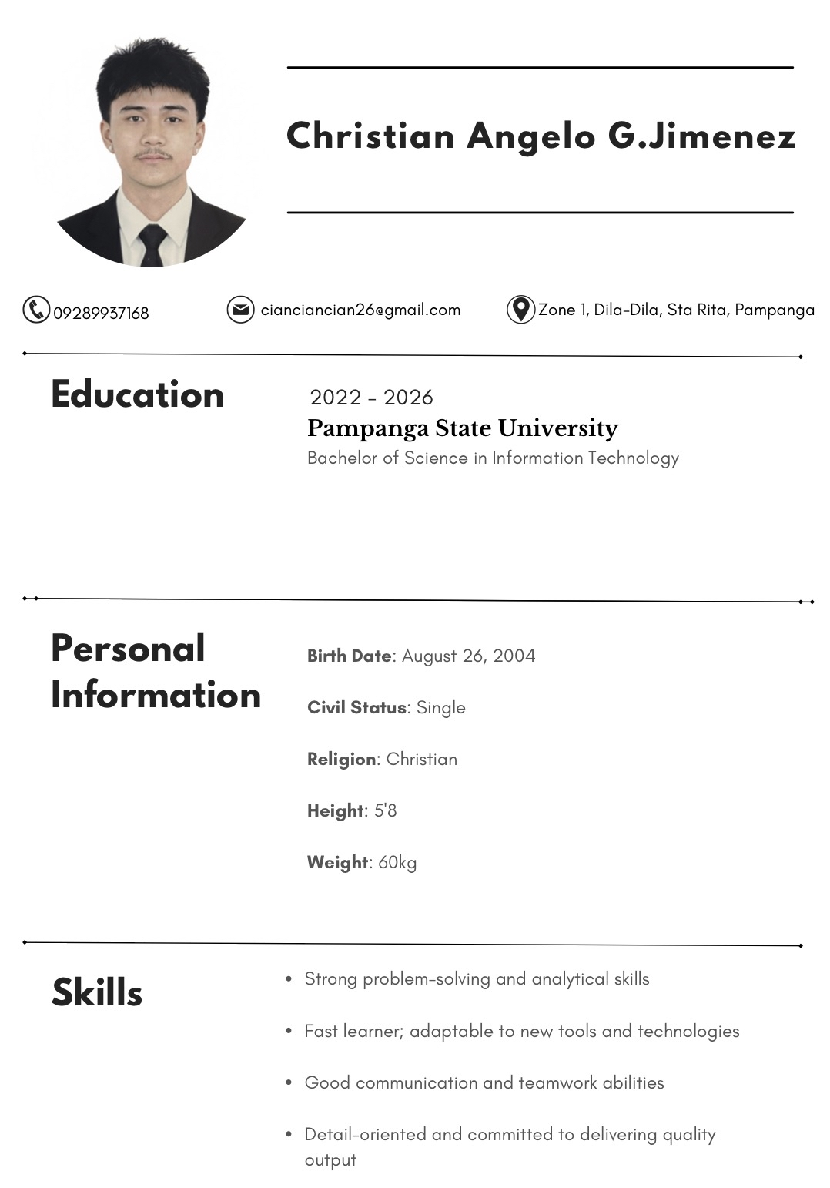





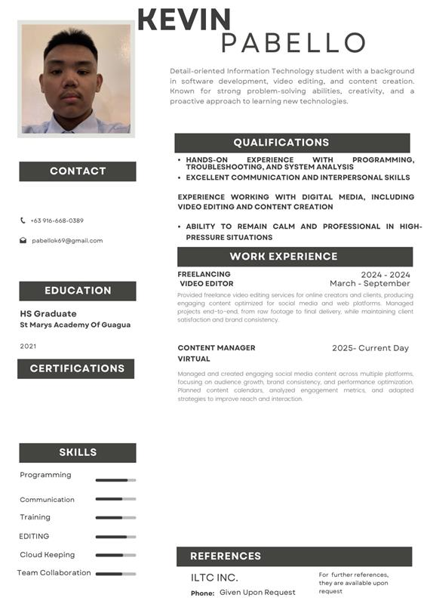

**Appendix J.**

Research Documentation Pictures

